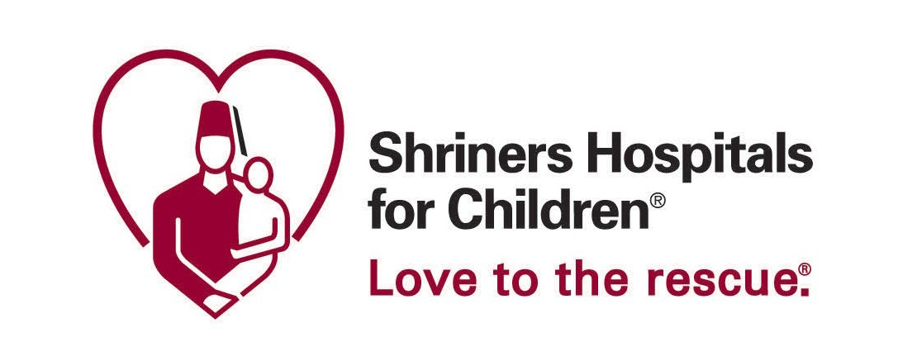Shriners Hospitals for Children Love – 30 Second Featuring President Jimmy Carter

30 SECOND VIDEO

Former President Jimmy Carter in front of a simple backdrop. B-Roll of photos from the Carter’s life showing them in love with each other and helping others. (Either full screen or in frames and filmed.)

President Carter on screen.

B-­‐‑roll of various Shriners Hospitals for Children locations and doctors/nurses helping children.

Full screen graphic with logo, telephone number, and website. Background is blurred video of an exterior shot of a Shriners Hospitals for Children hospital.

30 SECOND AUDIO
Our greatest legacy is not our accomplishments in life; it is what we can do to help the next generation.

Rosalynn and I are privileged to be ambassadors for Shriners Hospitals for Children.

These amazing children are an inspiration to everyone, and we’re grateful to become a part of this remarkable legacy at Shriners Hospitals for Children.

If you know a child they can help, please call or go online right now.

